Coil Array

This block takes in data from the environment to detect the strength of a nearby magnetic field. The strength of the magnetic field is represented as a voltage output from this block. When the magnetic field varies with time, the induced electromotive force is proportional to $\frac{dB}{dt}$[1]. Current is induced in the primary winding of the 1:1000 current transformer, producing a scaled secondary voltage across the burden resistor which is amplified 20 times with the AD8422 instrumentation amplifier. A 2.5V DC bias, generated by the power conditioning block shifts the voltage into the 0v to 5v range suitable for the unipolar input of the ADC. Finally, a lowpass filter is used to attenuate any remaining high frequency noise. This block was designed by Jack Fraley.

Description

This block provides a voltage output proportional to the magnetic field strength along each axis. The main components are the copper ring, a 1:1000 current transformer and a burden resistor, an AD8422 gain stage, and the power conditioning stage.

Design
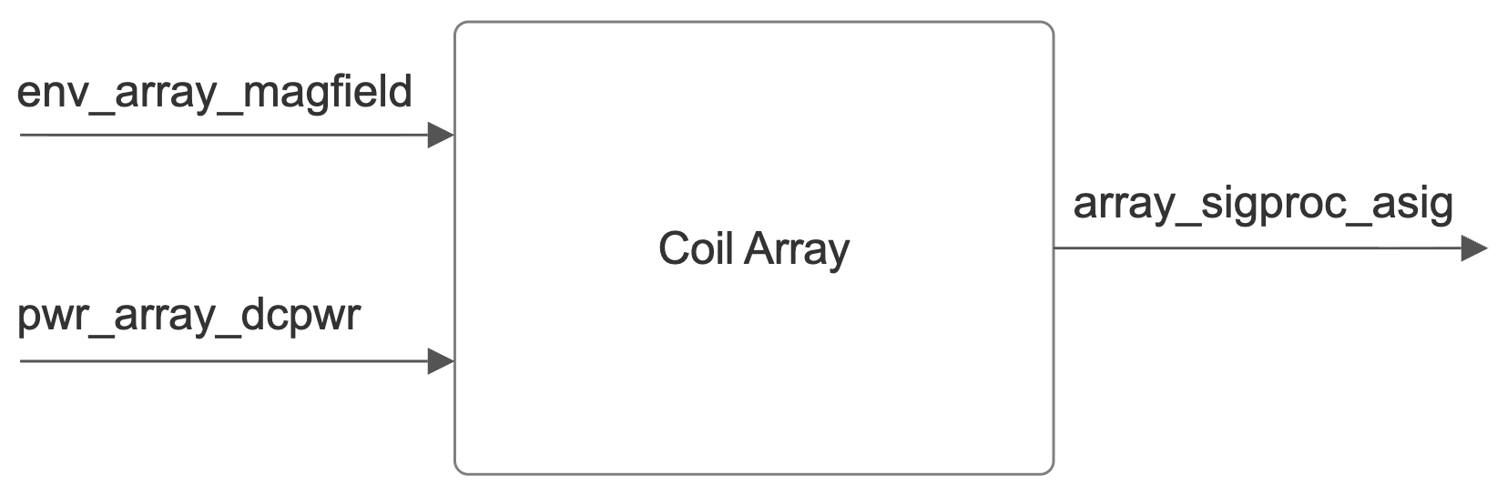

Fig. 4: Block Diagram of Coil Array

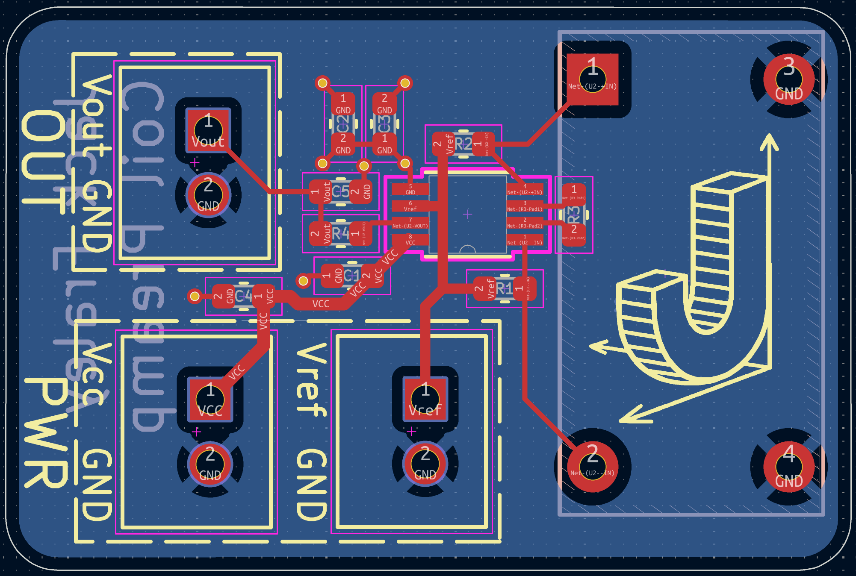

Fig. 5: PCB design of coil array block

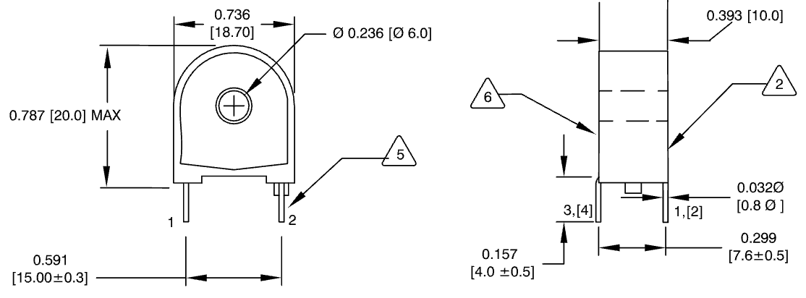

Fig. 6: Product Dimensions of CT-0705-HA Current Transformer [4]

$V=μπfa^{2}\frac{I}{r}$

Fig. 7: Primary Loop Induced Voltage From Magnetic Field [2].
μ is the permeability of water, f = 640Hz, a = 0.0635m, I = 4A and r is the distance from the center of the magnetic field.

$V=\frac{V_{1}}{R_{1}}\left(\frac{1}{1000}\right)R_{2}$

Fig. 8: Secondary Toroidal Current Transformer Voltage [3].
R1 = 0.0013Ω, R2 = 5kΩ + 5kΩ + 25Ω = 10,025Ω

$B=μ\frac{I}{2πr}$

Fig. 9: Magnetic Field Strength derived from Ampere’s Law [2].
μ is the permeability of water, and I = 4A

General Validation

This block needs to be able to accurately measure magnetic fields up to 10ft from the cable it is locating. The method for which the device detects a magnetic field is through a current induced in its sensing coil. This is done by the magnetic field perpendicular to the copper ring inducing a voltage following the right hand rule. The ring was chosen to have a diameter of 5in to maximize induced voltage while still being compact. The ring has only a single loop to prevent the three axes from interfering with one another. Our project partner specified that the typical signal sent through the cable to be detected is a 640Hz 4A signal. Based on those metrics the voltage induced in the primary loop at our engineering requirement of 10ft is 0.0133mV as calculated from the equation in figure 6.

The voltage induced in the primary loop is too small to be accurately measured so it needs to be stepped up with a current transformer. A 1000:1 current transformer is used to produce a voltage across a burden resistor higher than the voltage in the copper ring. The current transformer chosen is the CWS CT-0705-HA which can handle a primary current of up to 10A which is well above the maximum possible current that could be induced in the ring. The resistance of the primary loop is roughly 0.001Ω per foot and the circumference of the loop is 1.57ft so the resistance of the loop is 0.00131Ω. The resistance of the secondary winding is 25Ω for the CT-0705-HA current transformer and two 5kΩ burden resistors are used. Using these values and the equation in figure 7, the voltage induced in the current transformer at 10ft is 100mV.

The output of the current transformer is then given a 2.5V DC bias to prevent any negative voltages from being produced by this block. This 2.5V DC bias is provided from the power conditioning block which can provide a stable reference voltage without adding any noise to the system.

To make the output easier for the ADC to measure an instrumentation amplifier, specifically the Analog Devices AD8422, is used to step up the voltage [-]. The AD8422 is configured with decoupling capacitors to reduce any rail noise. The configurable gain resistor was chosen to set a gain of 20 to amplify the signal before it is read by the ADC. The AD8422 is powered by the 5V rail and ground. An ultra low noise reference voltage of 2.5v is also supplied to the device. This reference voltage is first made by stabilizing the output of the 5v rail with a TPS7A94 low drop out linear regulator and reducing the voltage down to 4.7v. The output of the linear regulator is then stepped down to 2.5v using ADR4525 which is rated for an ultra low noise output. Finally, the reference voltage input of the AD8422 needs to have low impedance so an OPA2211 precision opamp is used in the voltage follower configuration. This power conditioning allows for the reference voltage to be added without adding additional noise to the system. By adding Vref, the bipolar output of the current transformer can be used as an input for the unipolar ADC input pins.

Interface Validation

Env_array_magfield: Input
Magnetic Flux Max: 2.62μΤ | This is the maximum strength of the magnetic field under the conditions that our project partner will use this coil array in. | The maximum magnetic flux as calculated in figure 6 is 2.6μΤ with a distance of 0.3m and a cable current of 4A.
Magnetic Flux Min: 0.066μΤ | This is the minimum strength of the magnetic field when the coil is at a maximum distance from the cable of 3m. | The minimum magnetic flux as calculated in figure 6 is 0.066μT with a distance of 3m and a cable current of 1A.
Cable Current  Min: 1A | This is the minimum current to be sent through the test cable for creating the magnetic field. | The current passing through the cable is set externally with a high power signal generator which can achieve 1A of current.
Cable Current  Max: 4A | This is the maximum current to be sent through the test cable for creating the magnetic field. | The current passing through the cable is set externally with a high power signal generator which can achieve 4A of current.

Array_sigproc_asig: Output
Voltage Range Min: 0.5mV | This is the peak negative voltage the block will be capable of outputting under normal conditions when the 1A cable is over 10ft from the sensor. | The minimum voltage outputted by the block with a distance of 10ft and a cable current of 1A is calculated to be 0.5mA after the amplifier stage [2][3].
Voltage Range Max: 250mV | This is the peak voltage the block will be capable of outputting under normal conditions when the 4A cable is under 1ft from the sensor. | The maximum voltage outputted by the block with a distance of 1ft and cable current of 4A is calculated to be 250mA after the amplifier stage [2][3].
Frequency Max: 1061Hz | This is the maximum frequency this block will output to reduce unwanted noise. | Using a lowpass filter made from a 1kΩ resistor and a 150nF capacitor the frequency output can be limited to just over 1kHz.$f_{c}=\frac{1}{2π(1000)(150*1{0^{-9})}^{}}=1061Hz$
Frequency Min:  100Hz | This is the minimum frequency this block will be able to output. | The lowest frequency this block can output is the lowest frequency signal sent through the cable. Our project partner specified that no lower than 100Hz will be sent through the cable being detected so this block won't output anything less when a cable is within range.

Pwr_array_dcpwr
Voltage Max:  5.25V | This is the maximum voltage this block can be supplied with and still work properly. | This block is powered with a bench power supply so the voltage will be fixed to 5V. The maximum voltage the OPA1611 can handle is 5.5V and 5.25V is within that range.
Voltage Min:  4.75V | This is the minimum voltage this block can be supplied with and still work properly. | This block is powered with a bench power supply so the voltage will be fixed to 5V. To prevent the output from clipping, a voltage of no less than 4.75V may be supplied.
Current Max:  6mA | This is the maximum current this block will draw under normal conditions. | The OPA1611 has a maximum supply current of 5.1mA. The OPA187 has a maximum supply current of 250uA.
Current Min:  3mA | This is the minimum current this block will draw under normal conditions. | The OPA1611 has a nominal supply current of 3.6mA. The OPA187 has a nominal current of 350uA.

Verification Process

- Connect the test cable to the signal generator with a 250Ω resistor.
- Loop test cable around ring (8) times.
- Set signal generator to 640Hz at 2V to simulate a 4A at 1ft.
- Measure output voltage and verify a reading of 250mV ptp.
- Set the signal generator to 640Hz at 0.41V to simulate 4A at 5ft.
- Measure the output voltage and verify a reading of 48mV ptp.
- Set the signal generator to 640Hz at 205mV to simulate 4A at 10ft.
- Measure output voltage and verify a reading of 2.3mV ptp.
- Power of the signal generator, reduce the coil winding to (4) turns around the copper ring.
- Set the signal generator to 640Hz at 1V to simulate 1A at 1ft.
- Measure output voltage and verify a reading of 58mV ptp.
- Set the signal generator to 640Hz at 205mV to simulate 1A at 5ft.
- Measure output voltage and verify a reading of 11.7mV ptp.
- Set the signal generator to 640Hz at 100mV to simulate 1A at 10ft.
- Measure output voltage and verify a reading of 0.5mV ptp.

References

[1] H. Li, S. Chen and W. Huang, "Underwater Power Transmission Cable Positioning Method Based on Dual Triaxial Coil Sensors," 2024 9th Asia Conference on Power and Electrical Engineering (ACPEE), Shanghai, China, 2024, pp. 1991-1995, doi: 10.1109/ACPEE60788.2024.10532578.

[2] P. Wang, P. Lewin, K. Goddard and S. Swingler, "Design and testing of an induction coil for measuring the magnetic fields of underground power cables," 2010 IEEE International Symposium on Electrical Insulation, San Diego, CA, USA, 2010, pp. 1-5, doi: 10.1109/ELINSL.2010.5549557.

[3] W. Storr, “Current transformer basics and current transformer theory,” Basic Electronics Tutorials, https://www.electronics-tutorials.ws/transformer/current-transformer.html

